Test Specification
For
<Hermes>

Instructor: | Fang Zheng/ Keiwei Mao
Team Members: | Jiang Zhou/ Jiacheng Shen/ Hanwen Zheng/ Zichao Zhao
Cycle: | 1
Date Submitted: | June 22, 2019

Document template copyright 2005-2015, CCI Instructors. Version 2.2. Use permitted under Creative Commons license CC-BY-NC-SA. See http://creativecommons.org/licenses/by-nc-sa/3.0/.

Grading Rubric – Test Specification
This rubric outlines the grading criteria for this document. Note that the criteria represent a plan for grading. Change is possible, especially given the dynamic nature of this course. Any change will be applied consistently for the entire class.

Achievement | Minimal | Exemplary | Pts | Score
Content | Section(s) missing, not useful, inconsistent, or wrong. | Provides all relevant information correctly and with appropriate detail
Introduction |  |  | 0.5
Gantt chart |  |  | 0.5
Issues list |  |  | 0.5
Test Specs
Selection | Aspects tested are trivial | Tests clearly address core system functions | 2
Organization | Tests are disorganized, IDs or Objectives are not meaningful | Tests are well-organized with structured IDs and clear objectives | 2
Set-up | Steps are unclear or incomplete | Complete, easy to follow conditions and steps | 2
Results | Unclear or incomplete | Complete and clear | 1
Grammar and Spelling | Many serious mistakes in grammar or spelling | Grammar, punctuation, and spelling all correct | 0.5
Expression | Hard to follow or poor word choices | Clear and concise. A pleasure to read | 0.5
Tone | Tone not appropriate for technical writing | Tone is consistently professional
Organization | Information difficult to locate | All information is easy to find and important points stand out | 0.5
Layout | Layout is inconsistent, visually distracting, or hinders use | Layout is attractive, consistent, and helps guide the reader
Late Submission
Total |  |  | 10

Test Specifications

<This project is a reward system. And its users are basically students of this major. In this system, students are divided into two groups: users of information and publishers of information. Users will download and evaluate class resources, and publishers will post their own resources and receive rewards based on user feedback.The roles of the two groups are readily interchangeable, with publishers able to download their own resources and users able to upload their own resources. Our team will be responsible for the later operation and provide awards. This project can effectively promote students to help each other and share their learning resources. For any participant in the domain (such as CI 102), everyone will use their own account to access the platform. Moreover, all data will be stored in the database we created.>
<Gantt Chart
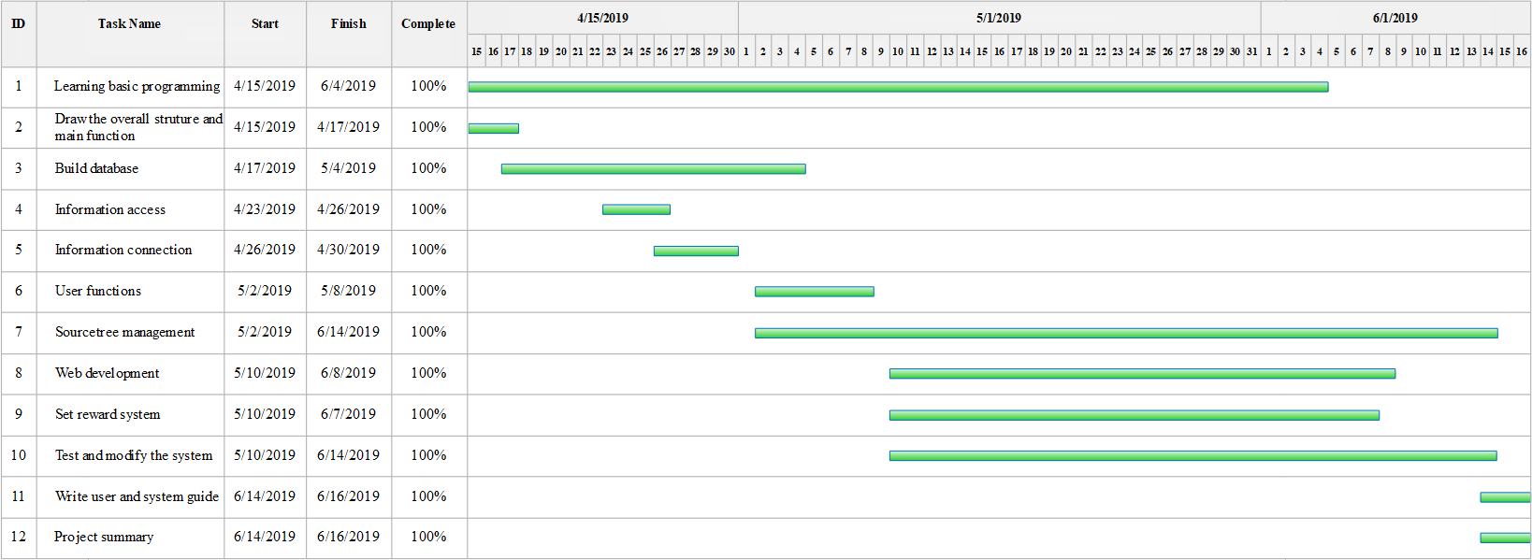 >

<Design Entity 1> - <File upload/Download function>
<Test 001> - <Test of file upload function> (<Jiacheng Shen>)
Objective | To check if the function can work well, which allow users to upload files into our website, and the uploaded files can be found in our database with completeness and in the upload record.
Set-up | In this test, a file upload function is created. Tester need to use this function to upload different types of files(doc, docx, txt, jpg, py files) and check the personal center upload record.
Expected Results | We can find the uploaded files in our database, and the files remain complete. The file name can be found in the upload record.
Actual Results | The upload function can run normally.

<Test 002> - <Testing of download function> (<Jiacheng Shen>)
Objective | To check if the download function can work well, which allow users to download the files in our website and
Set-up | Tester should find all kinds of files mentioned in Test 001 in our database, which should be uploaded in advance. Then, use download function to download them, and check if the download process can work successfully and if the downloaded files remain complete.
Expected Results | Download successfully, and the files remain complete.
Actual Results | The download function can run normally.

<Design Entity 2> - <Login function>
<Test 001> - <Test of login function> (<Jiacheng Shen>)
Objective | To check if our users can login into our website by typing username and password and if it will raise error when inputting invalid username or password.
Set-up | A login function is built in the website. Tester should use the function to login by typing in username and password that are registered before.
Expected Results | If typing right username and password, login successfully, personal information should be shown in personal center. If typing wrong username and password, login failed.
Actual Results | The login function can run normally.

<Design Entity 3> - <Search function>
<Test 001> - <Test of reward exchange function> (<Jiacheng Shen>)
Objective | To test if the reward exchange function can work well, which allow users to exchange score to reward..
Set-up | In this test, user gets amount of score to exchange reward.
Expected Results | User can get reward and his score is reduced.
Actual Results | The reward exchange function can run normally.

<Design Entity 4> - <The interaction between uploading files and database>
<Test 001> - <Whether the files are uploaded> (<Hanwen Zheng>)
Objective | User uploads the files to the system. It’s about testing the detailed process of uploading by checking in the database.
Set-up | In this test, a file upload function is created. The tester inputs the name of the file which is uploaded and check whether the data of name and file are in the database.
Expected Results | The name and the file are stored in the database of the files.
Actual Results | The name and the file are stored in the database of the files.

<Test 002> - <The completeness of the uploaded file> (<Hanwen Zheng>)
Objective | User uploads the files to the system. It’s more about the testing the completeness of the uploaded file by checking the data of uploaded file in the database.
Set-up | In this test, a file upload function is created. The tester inputs the name of the file which is uploaded. And then he will check the data in the database whether the file is complete.
Expected Results | The content of the file is complete and same as the initial uploaded file.
Actual Results | The content of the file is complete and same as the initial uploaded file.

<Design Entity 5> - <The interaction between login function and database>
<Test 001> - <The authority after login> (<Hanwen Zheng>)
Objective | User logs in our system. It’s about testing the authority of the users after logging in the system by checking the user information in the database.
Set-up | In this test, a user login function is created.The tester inputs the right account and password. And then he checks the data of account and password in the database and make sure the user will get all the authority.
Expected Results | The account and password get matched in the database and can get the corresponding authority.
Actual Results | The account and password get matched in the database and can get the corresponding authority.

<Design Entity 6> - <The interaction between the downloading file and database>
<Test 001> - <Searching result> (<Hanwen Zheng>)
Objective | User searches the uploaded file and downloads it. It’s more about the testing the searching result by matching it with the data in the database.
Set-up | In this test, a searching function is created. The tester inputs the name of the uploaded file to the searching function and check the result in the database to find whether the result can get matched in the database.
Expected Results | The name in the database can get matched.
Actual Results | The name in the database can get matched.

<Test 002> - <Downloading files> (<Hanwen Zheng>)
Objective | User searches the uploaded file and downloads it. It’ s more about testing the downloading files from the database after searching.
Set-up | In this test, a downloading function is created. The tester inputs the name of the uploaded file and download it. And then check the file in the database whether can be downloaded and complete.
Expected Results | Data of file in the database can get matched and can be downloaded.
Actual Results | Data of file in the database can get matched and can be downloaded.

<Design Entity 7> - < Systems integration testing >
<Test 001> - <Login systems integration testing> (<Zichao Zhao>)
Objective | To check whether our system can work well, which is that users can login in it and get their corresponding authority to upload and download files, check their reward score and exchange awards.
Set-up | In the test, user logins in the system, upload, download files check the score and exchange awards.
Expected Results | User can login in the system and get the corresponding authority to upload and download files, check their reward score and exchange awards
Actual Results | The system can run normally.

1.8 <Design Entity 8> - <Stress testing >
<Test 001> - <Login function stress testing> (<Zichao Zhao>)
Objective | To check whether our login function can support many users login in it and get at the corresponding authority same time.
Set-up | In this test, tester use a script to input many users account and password at same time.
Expected Results | All users can log the system and get the corresponding authority.
Actual Results | The login function can run normally.

<Test 002> - <Upload function stress testing> (<Zichao Zhao>)
Objective | To check whether our upload function can support many users upload files in the system at the same time and whether the upload record is accurate.
Set-up | In this test, tester use a script to upload many files regardless of types of files in our system.
Expected Results | The files can be uploaded and search in the database and can be matched in uploaded and the download count is accurate.
Actual Results | The upload function can run normally.

<Test 003> - <Download function stress testing> (<Zichao Zhao>)
Objective | To check whether our download function can support many users download files in the system at the same time, and whether the download count is accurate.
Set-up | In this test, tester use a script to download many files regardless of types of files in our system.
Expected Results | The files can be downloaded and can be matched in the database and the download count is accurate.
Actual Results | The download function can run normally.

1.9 <Design Entity 9> - < Systems testing >
<Test 001> - < Reward score function > (<Zichao Zhao>)
Objective | To check whether we download or click like of the file, the score of user is increasing.
Set-up | In this test, tester download and click like of the file in our system. And login the uploader account to check the score.
Expected Results | The score increases according to the expected value.
Actual Results | The reward score function has error that the score is superimposing. And after changing code of the function the score is normal.

<Test 002> - < File upload/Download function > (<Zichao Zhao>)
Objective | To check whether when two users login and upload or download the files the file upload/download function can run normally.
Set-up | In this test, tester login two account and upload/download the files in the same subject.
Expected Results | The files can be uploaded and download without any error.
Actual Results | The system shows error because when use the upload/download function the program choose user again so it shows error. And after changing the code the function can run normally.

<Test 003> - < Language of Buttons > (<Zichao Zhao>)
Objective | To check whether the website and the web backend link normally.
Set-up | In this test, tester login the account and browse every website to check whether it links normally
Expected Results | Every website is normal and it can realize function in the backend.
Actual Results | The language of button is Chinese. By using JavaScript to create text box covering the button and create functions to encode the button, the language of button is English.

